DAILY ONLINE ACTIVITIES SUMMARY

|  |  |  |  |  |  |  |  |
| --- | --- | --- | --- | --- | --- | --- | --- |
| **Date:** | **30-06-2020** | | | | **Name:** | **Kavya.R.Shetty** | |
| **Sem & Sec** | **6th sem, ‘A’ sec** | | | | **USN:** | **4AL17CS042** | |
| Online Test Summary | | | | | | | |
| **Subject** | | **Java and J2EE** | | | | | |
| **Max. Marks** | | **-** | | **Score** | | **-** | |
| Certification Course Summary | | | | | | | |
| **Course** | - | | | | | | |
| **Certificate Provider** | | | **-** | **Duration** | | | **-** |
| Coding Challenges | | | | | | | |
| **Problem Statement: 1 Java program and 1 C program** | | | | | | | |
| **Status: executed** | | | | | | | |
| **Uploaded the report in GitHub** | | | | **Yes** | | | |
| **If yes Repository name** | | | | <https://github.com/kavya-shetty765/DAILY-> [STATUS](https://github.com/nandithashetty/DAILY-STATUS) | | | |
| **Uploaded the report in slack** | | | | **Yes** | | | |

# Online Test Details:

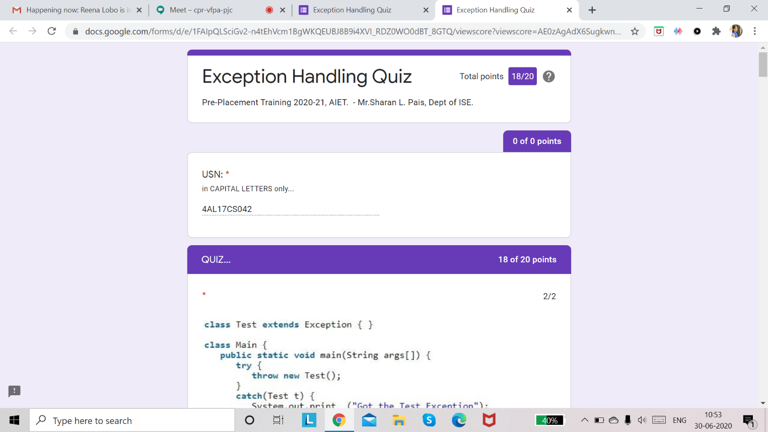

**Coding Challenges Details:**

**Program 1**

This is output of java program to determine whether one string is a rotation of another.

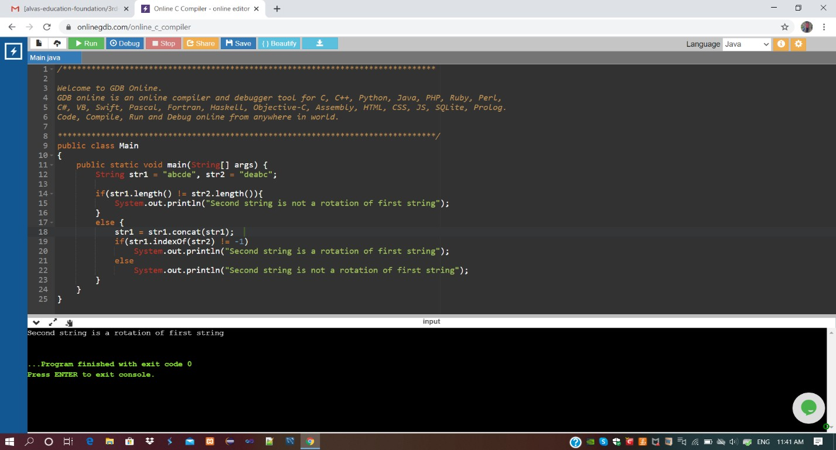

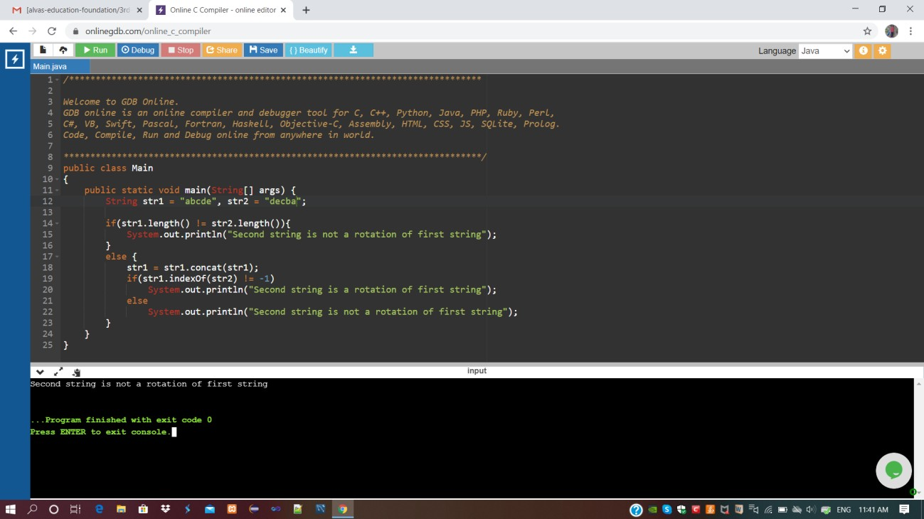

**Program 2**

This is output of C program to generate first n Ugly Numbers.

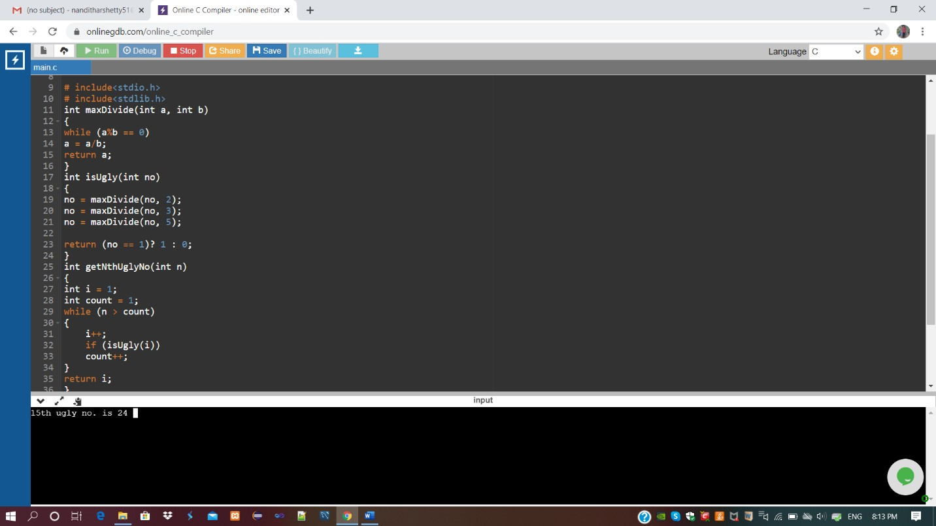

Refer GitHub for detailed Information:

<https://github.com/kavya-shetty765/DAILY-STATUS/tree/master/30-06-> [2020/ONLINE%20CODING](https://github.com/nandithashetty/DAILY-STATUS/tree/master/30-06-2020/ONLINE%20CODING)

This Report is also available in:

<https://github.com/kavya-shetty765/DAILY-STATUS>